S E N I O R S H R E E R A M M O D E L S C H O O L
I – ENGLISH A S S I G N M E N T 2020– 2021
Chapter :- 4 Vani’s Family

WORD – MEANINGS

S.No. | WORD | MEANING
1. | Live | Living
2. | Talk | Discussion
3. | Meet | Join
4. | Hide | Escape
5. | Grandma | Father’s mother
6. | Catch | To grasp
7. | Seek | To look for

MAKE SENTENCES

S.No. | WORD | SENTENCE
 | Members | Small family has five members.
 | Meet | I meet with my friend.
 | Takes | My grandma takes me to park.
 | Artist | My father is an artist.
 | Catch | A cat catch a mouse.

One word- Answer
Q.1 How old is Sara ?
Ans. Three years old .
Q.2 How old is Vani ?
Ans. Six years old .
Q.3 What does Sara like to do ?
Ans. Play with Vani .
Q.4 What does Vani’s mother love to do ?
Ans. Paint .
Q.5 Where does Vani’s family live ?
Ans. Agra .
***************

Chapter – 4 Vani’s Family
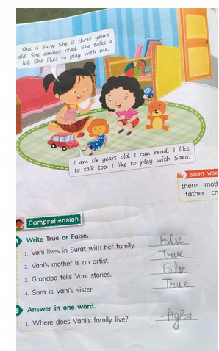
Book exercise

